Pearson Online Textbook Access 2017-2018

Greetings Parents! This letter will provide you with simple instructions for how to access the student textbook online in social studies. This access is provided free of charge and can be used for make up work, studying or even homework.

Step #1: Please enter the link below into your web browser: pearsonsuccess.net

Step #2: After going to this link the page you arrive at should look like this:

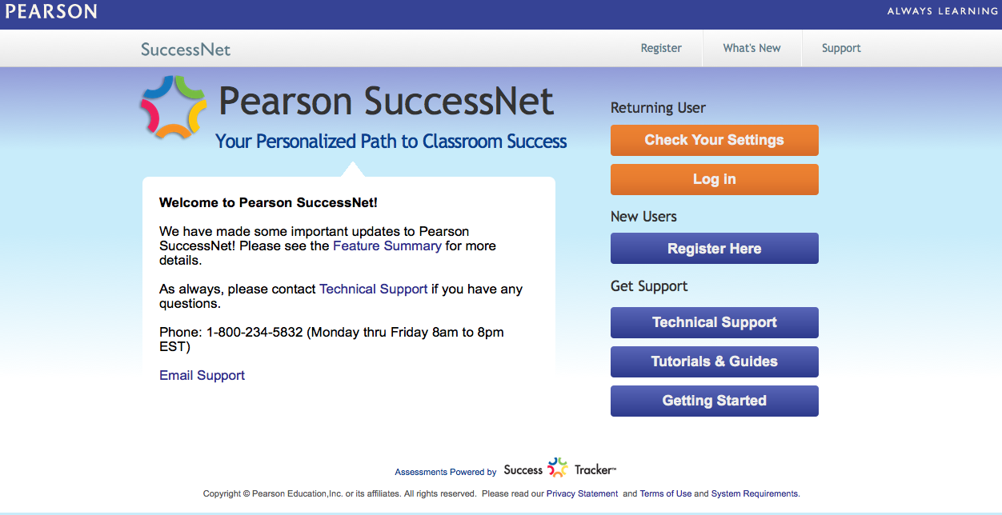

Step #3: From this page, you are going to click on the Orange button that says "Log In" under the heading on the right that says: "Returning User" [see below]
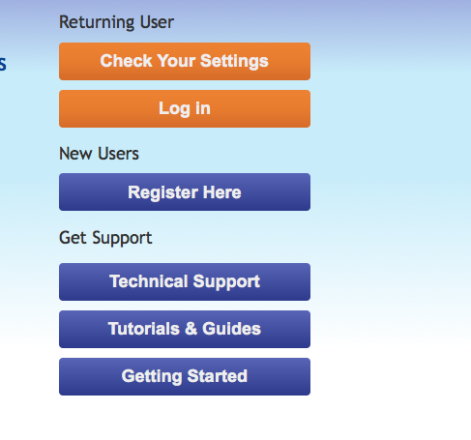
Step #4: In the username box type: amsbobcat2017

In the password box type: @rlington

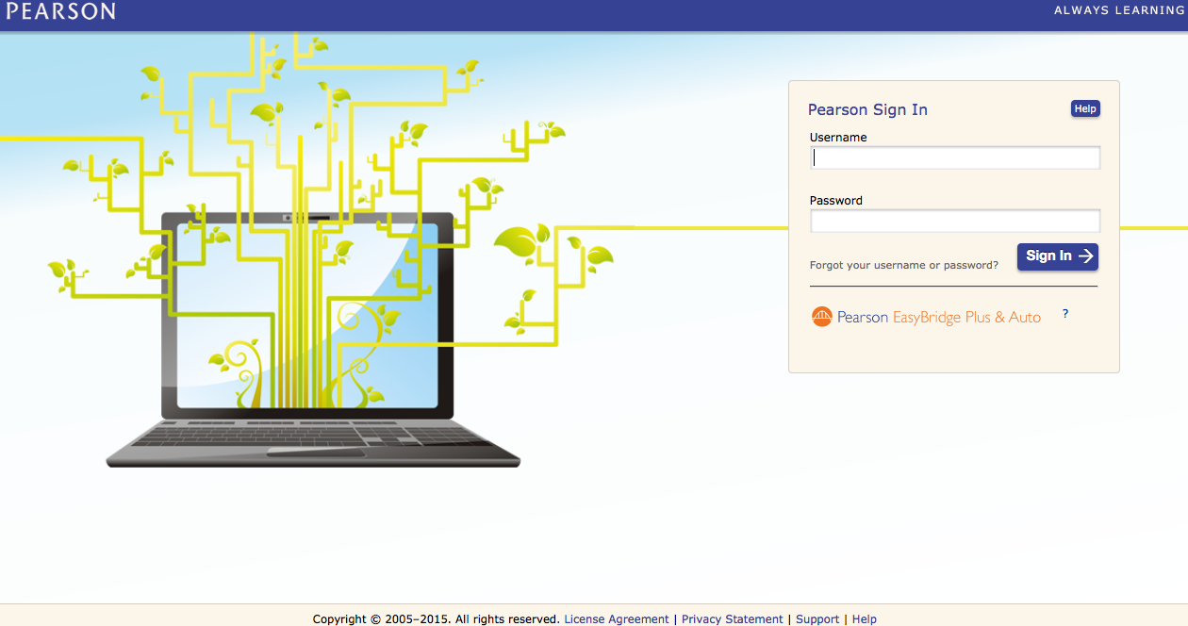

Step #5: After successfully logging in, the page you arrive at should look like this:
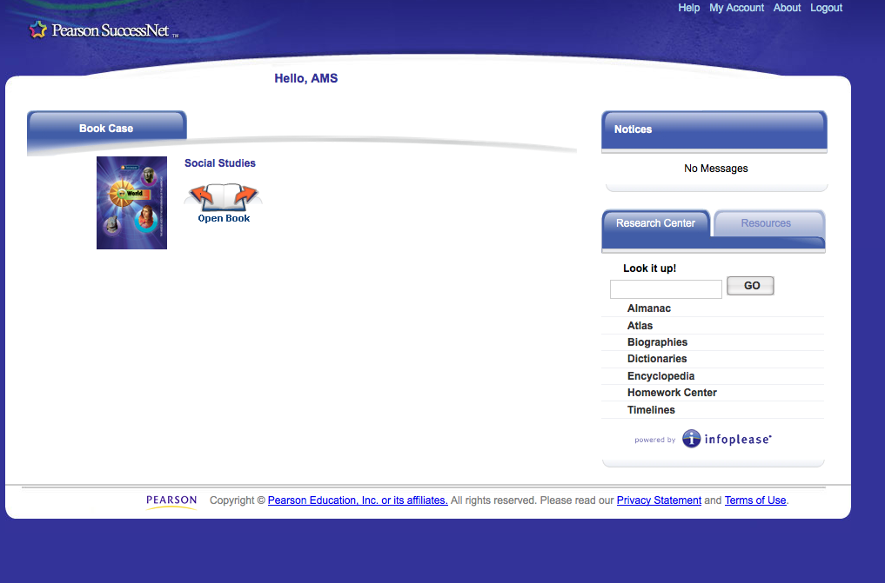

From this page, click on the "open book" icon next to the cover of the student textbook [make sure any popup blockers have been disabled in order for this to work]
Step #6: Use either the arrow keys in the top left or type in the page number you wish to go in the box to the right of the arrow keys.
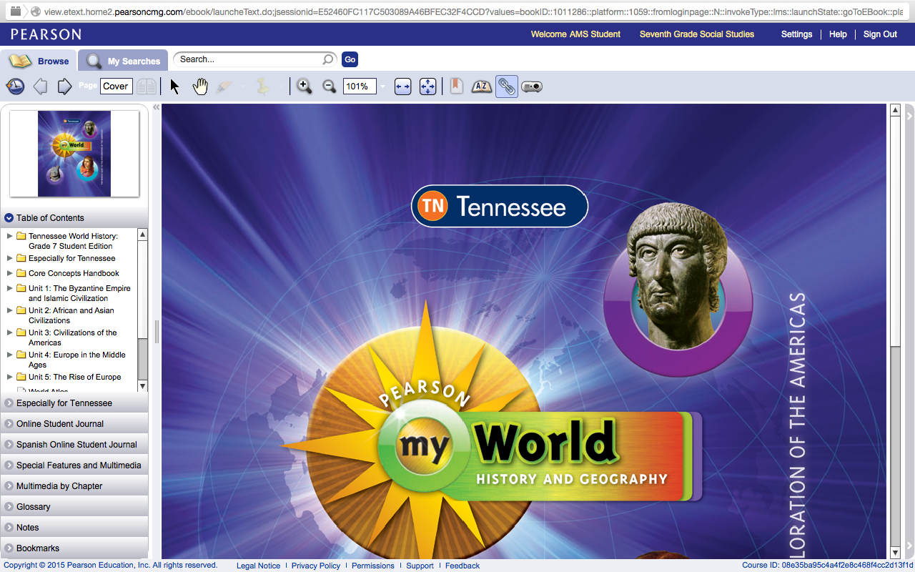

You could also use the "table of contents" bar on the left to navigate the textbook by Units of study and Sections within that Unit.

If you have any questions about how to access your textbook online, please contact me at: jonathan.hawkins@acsk-12.org

Thanks again for your devotion to your child's education and taking the time to read this letter!

Sincerely,
AMS Seventh Grade Social Studies Team

